OpenCart Website
Tutorial 7 — Boundary Value Analysis (BVA) & Equivalence Partitioning (EP)
Module Name: OpenCart – Registration / Login Username Validation
Report ID: TR7_001
Webpage URL: https://demo.opencart.com/en-gb?route=account/register

Aim
To apply Boundary Value Analysis (BVA) and Equivalence Partitioning (EP) to the username field of the OpenCart website forms.

Requirement Under Test
- Username length must be 5 to 15 characters (assumed requirement from the tutorial).
- Username cannot be blank.
- Password cannot be blank.

Parameter Details
Module Name | Registration / Login Username
Project Name | OpenCart Website Testing
Application | OpenCart (opencart.com) – executed on the official demo store, demo.opencart.com
SDLC Model | Waterfall Model
Technique | Black Box (EP + BVA)
Test Environment | Windows / Google Chrome
Tester Name | Student Name
Test Date | 15/08/2026

Test Cases
TC ID | Scenario | Input | Expected Result | Actual Result | Status
EP-01 | EP – Invalid partition (< 5) | abc (3 chars) | Username rejected | Register page has no Username field (First Name, Last Name, E-Mail, Password only) – length rule cannot be applied | Blocked
EP-02 | EP – Valid partition (5-15) | student1 (8 chars) | Username accepted | Register page has no Username field (First Name, Last Name, E-Mail, Password only) – length rule cannot be applied | Blocked
EP-03 | EP – Invalid partition (> 15) | studentmanagement1 (18 chars) | Username rejected | Register page has no Username field (First Name, Last Name, E-Mail, Password only) – length rule cannot be applied | Blocked
BV-01 | BVA – Minimum - 1 | abcd (4 chars) | Username rejected | Register page has no Username field (First Name, Last Name, E-Mail, Password only) – length rule cannot be applied | Blocked
BV-02 | BVA – Minimum | abcde (5 chars) | Username accepted | Register page has no Username field (First Name, Last Name, E-Mail, Password only) – length rule cannot be applied | Blocked
BV-03 | BVA – Minimum + 1 | abcdef (6 chars) | Username accepted | Register page has no Username field (First Name, Last Name, E-Mail, Password only) – length rule cannot be applied | Blocked
BV-04 | BVA – Nominal | abcdefghij (10 chars) | Username accepted | Register page has no Username field (First Name, Last Name, E-Mail, Password only) – length rule cannot be applied | Blocked
BV-05 | BVA – Maximum - 1 | abcdefghijklmn (14 chars) | Username accepted | Register page has no Username field (First Name, Last Name, E-Mail, Password only) – length rule cannot be applied | Blocked
BV-06 | BVA – Maximum | abcdefghijklmno (15 chars) | Username accepted | Register page has no Username field (First Name, Last Name, E-Mail, Password only) – length rule cannot be applied | Blocked
BV-07 | BVA – Maximum + 1 | abcdefghijklmnop (16 chars) | Username rejected | Register page has no Username field (First Name, Last Name, E-Mail, Password only) – length rule cannot be applied | Blocked
BL-01 | Blank Username | (leave empty) | Required-field / error message shown | No execution evidence supplied | Not Executed
BL-02 | Blank Password | (leave empty) | Required-field / error message shown | No execution evidence supplied | Not Executed

Execution Evidence
Execution Evidence — Register page (EP-01 to BV-07)
Steps
- Open the demo store (demo.opencart.com).
- Click My Account and choose Register.
- Inspect the Register Account form for a Username field.
Actual Result: The form contains only First Name, Last Name, E-Mail, Password and a Newsletter option. There is no Username field, so the 5–15 character rule could not be applied; EP-01 to BV-07 are marked Blocked.
Status: Blocked
Screenshot:
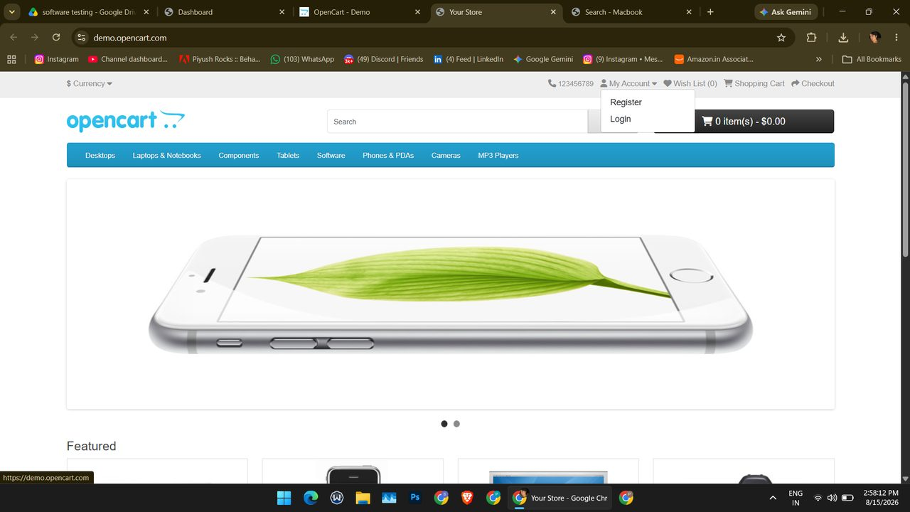
Screenshot (139)
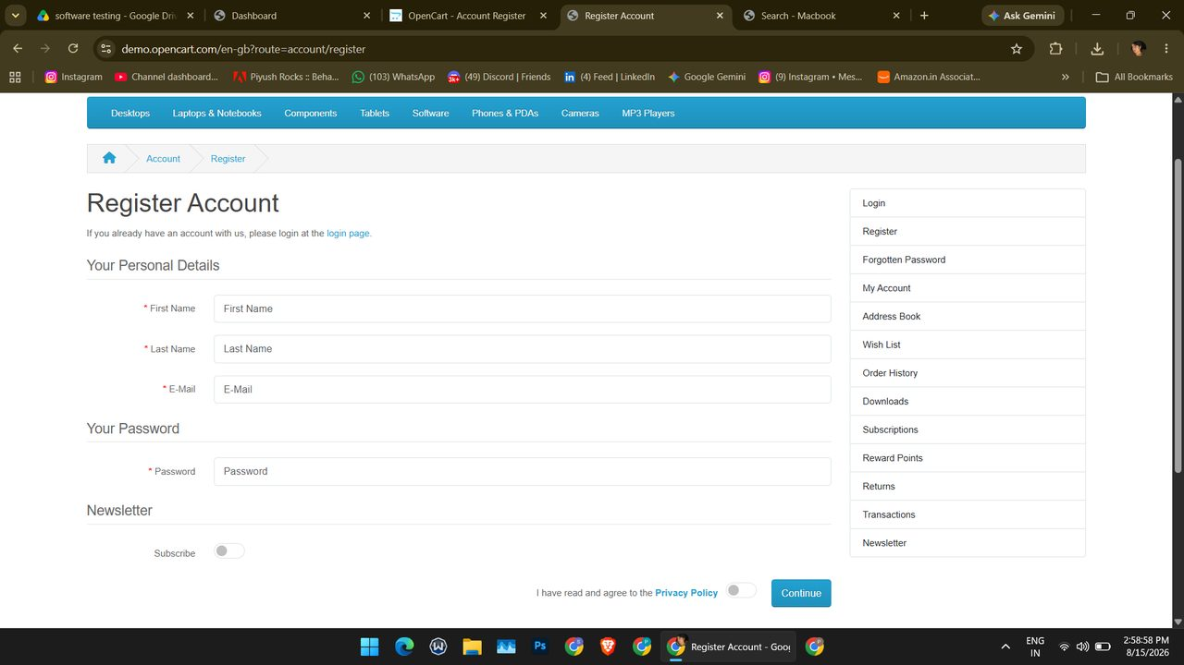
Screenshot (141)

Summary of Execution
Metric | Value
Total test cases | 12
Executed (Pass + Fail) | 0
Passed | 0
Failed | 0
Blocked | 10
Not Executed | 2
Pass % of executed | 0%
Pass % of total | 0.0%

